**To integrate Jenkins with SonarQube**

Prerequisite on Sonar server

* Git
* Java 11 open jdk
* Unzip
* Sonarqube
* wget

Link to download sonarqube

<https://binaries.sonarsource.com/Distribution/sonarqube/sonarqube-6.7.7.zip>

* commands
* wget https://binaries.sonarsource.com/Distribution/sonarqube/sonarqube-6.7.7.zip
* ls
* unzip sonarqube-6.7.7.zip
* cd sonarqube-6.7.7
* cd bin/linux-x86-64/
* sudo alternatives --config java
* sh sonar.sh start
* sudo netstat -tulpn

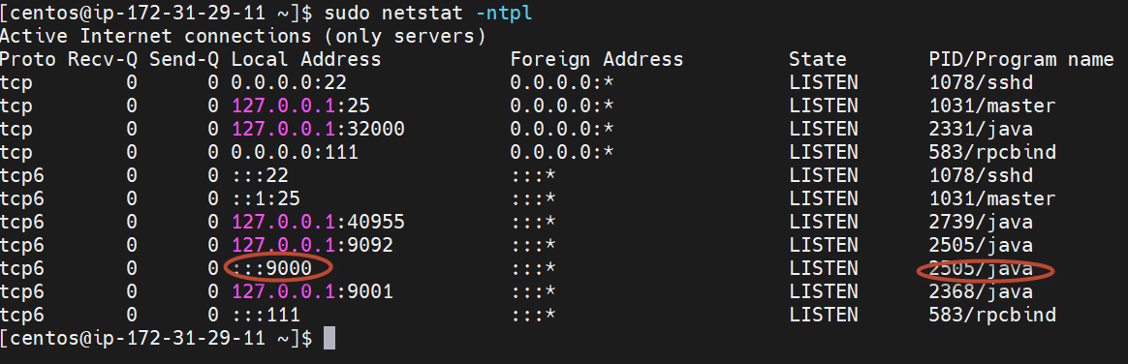

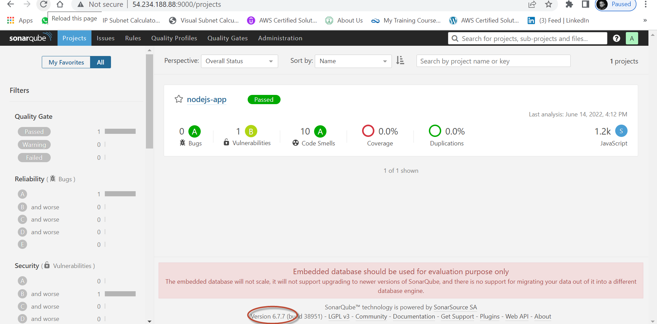

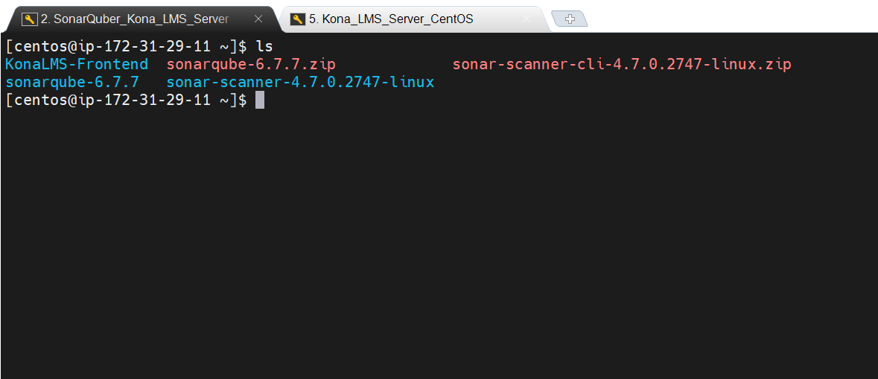

Sonar scanner can be downloaded from below link

<https://binaries.sonarsource.com/Distribution/sonar-scanner-cli/sonar-scanner-cli-4.7.0.2747-linux.zip>

* Now goto Jenkins servers

Prerequisite on Jenkins Server

Install the following

* wget https://binaries.sonarsource.com/Distribution/sonar-scanner-cli/sonar-scanner-cli-4.7.0.2747-linux.zip
* unzip sonar-scanner-cli-4.7.0.2747-linux.zip
* cd sonar-scanner-4.7.0.2747-linux/
* cd bin
* pwd
* export PATH=$PATH:/home/centos/sonar-scanner-4.7.0.2747-linux/bin
* sonar-scanner

Now Browse the sonar server

To generate a Token in Sonar server

(Note : u can should copy the token while first run of sonar or u can create by following the steps below)

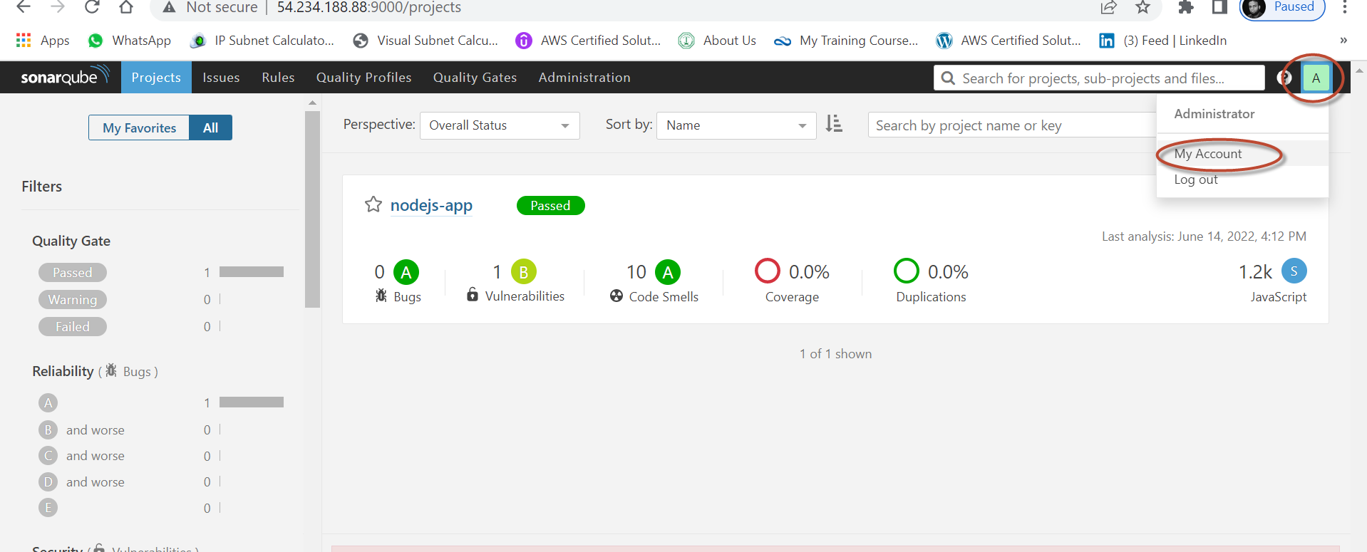

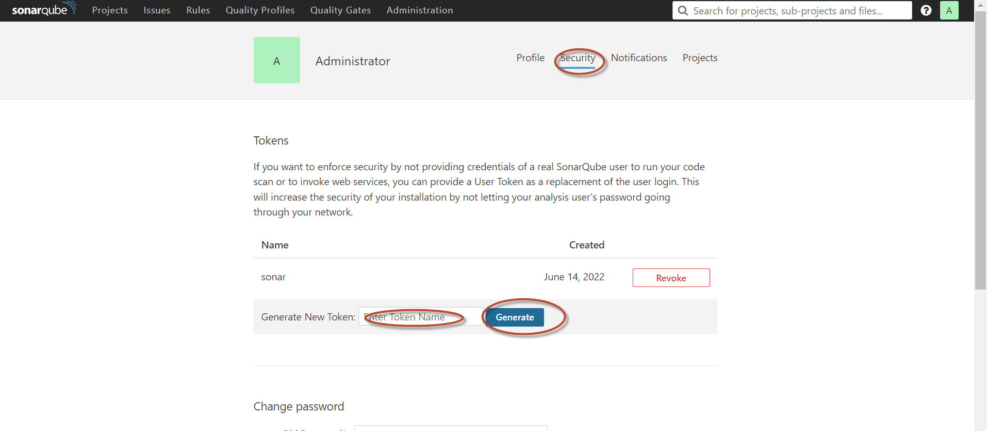

Jenkins configuration to integrate with sonar

Plugins required

Nodejs

Sonar scanner

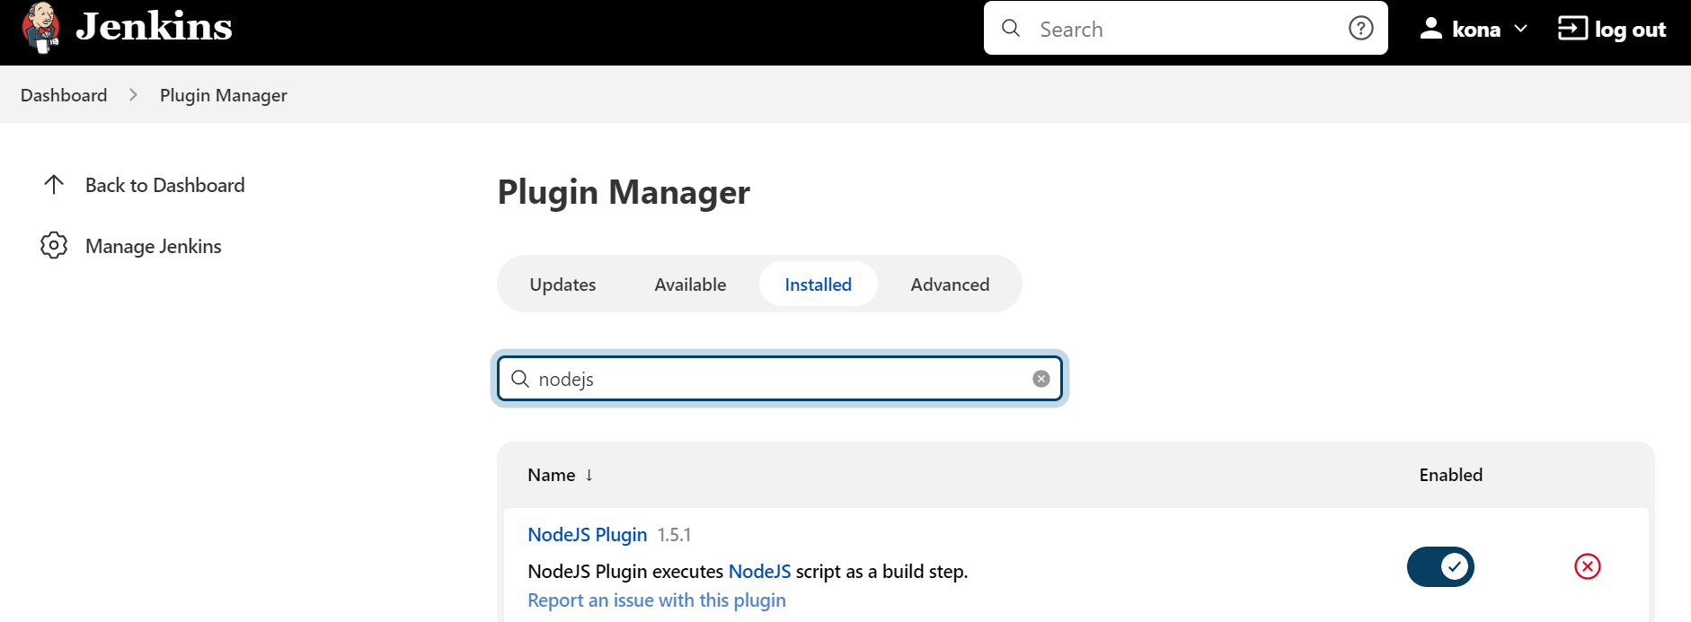

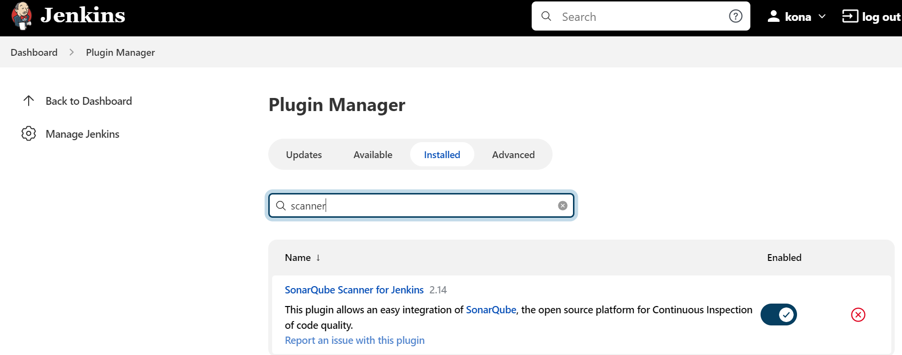

Note: need to restart the Jenkins server after successfully installation of plugins

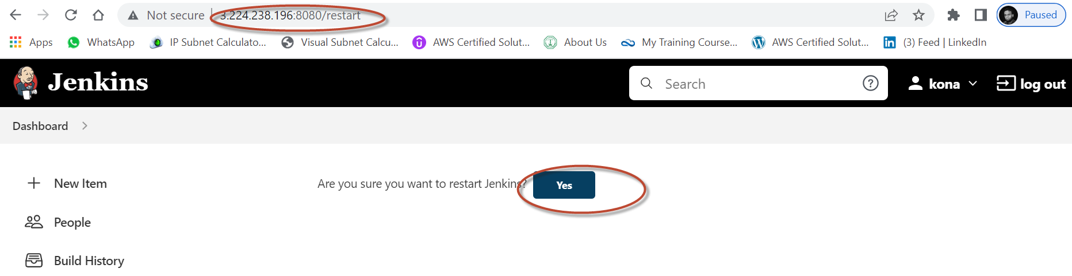

Now goto global tools configuration to configure the node js and sonar scanner (installed plugins)

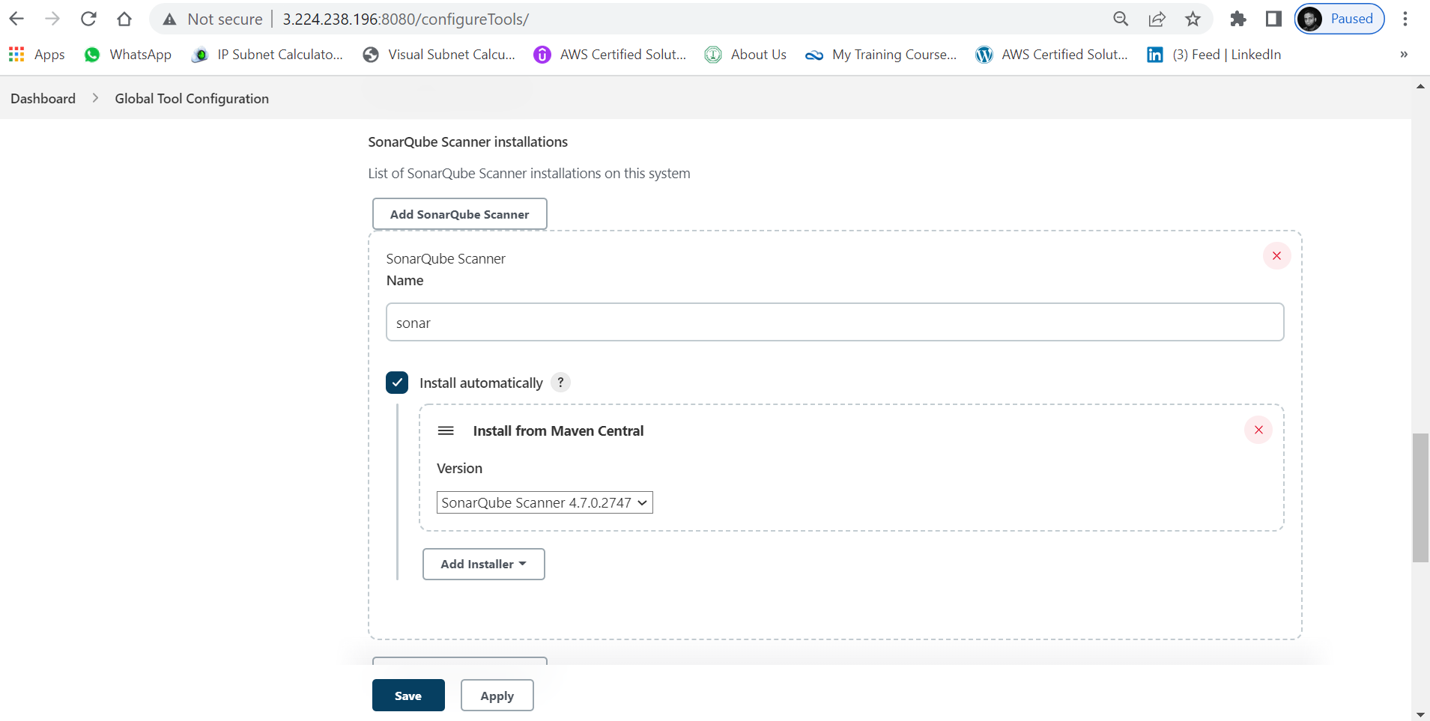

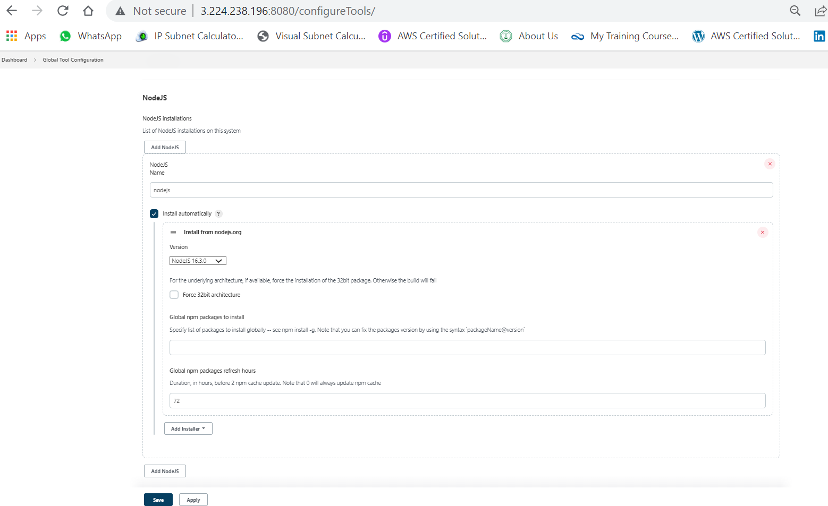

Done with integration of sonar scanner and nodejs installation on Jenkins

SonarQube pipe line script to generate the test results

stage('SonarQube Analysis') {

steps {

sh "npm install"

sh "npm install sonar-scanner"

sh "npm run sonar-scanner -Dsonar.projectKey=lms1234 -Dsonar.sources=. -Dsonar.host.url=http://54.234.188.88:9000 -Dsonar.login=d1ca4f24ca368c0006eacf1b12d82197abce7ce2"

}

}

